Single Anchor Plate (304 Stainless Steel)
  PRODUCT NAME | Stainless Steel Single Anchor Plate (304 Stainless Steel) | 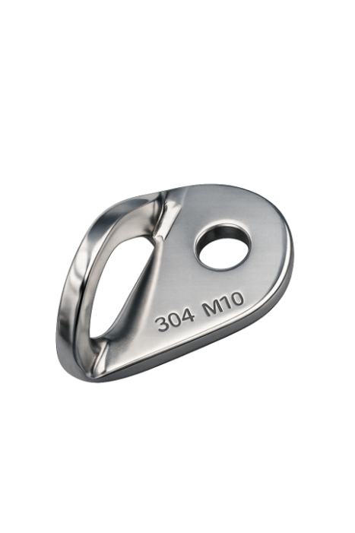
PRODUCT CODE | DEC-AP-M10-304
PRODUCT CATEGORY | Horizontal Lifeline Component
MATERIAL | Marine Grade SS316 Stainless Steel
PRODUCT DESCRIPTION
This stainless-steel single anchor plate is manufactured from corrosion-resistant 304 stainless steel and is designed as a permanent or semi-permanent anchorage component for fall protection and rope access systems. The smooth rounded profile minimizes connector wear while providing a strong, reliable attachment point when installed by a competent person.


KEY FEATURES |  | APPLICATIONS
 | Marine Grade SS316 Stainless Steel | - Horizontal Lifeline Systems
 | Excellent Corrosion Resistance | - Roof Safety Systems
 | Adjustable Cable Tension | - Industrial Structure
 | Easy Installation | - Mining Facilities
 | Suitable for Permanent Lifeline Systems | - Telecommunications Towers
 | Low Maintenance Design | - Solar Panel Installations
 |  | - Rope Access Safety Systems

TECHNICAL SPECIFICATIONS
SPECIFICATION | VALUE | SPECIFICATION | VALUE
Material | SS316 Stainless Steel | Weight | Editable
Finish | Polished | Working Load Limit (WLL) | 8 - 12 kN
Thread Type | Metric | Static Load Test | 20 kN
Thread Size | M14 | Dynamic Load Test | 15 kN
Overall Length | 320mm | Ultimate Failure Load | 50 kN
Adjustment Range | 430mm | Safety Factor | 5:1
Jaw Width | 25mm
Pin Diameter | 12mm


COMPLIANCE & STANDARDS
This product is manufactured and tested in accordance with international and South African standard including.
EN  795 | EN  353 | EN  362 | SANS  50353 |  | SANS  50795 | SANS  795 | ISO  9001
Personal Fall Protection Anchor Devices | Guided Type Fall Attachment | Connectors for Personal Protection Equipment | Personal Fall Protection Anchor Devices |  | Anchor Device | Fall Protection Anchor Devices | Quality Management Manufacturing Systems

INSTALLATION REQUIREMENTS

- Installation in accordance with applicable engineering designs and specification.
- Horizontal lifeline range is based on the sound engineer principles.
- Ensure correct wire cable fusion to anchor point.
- Use Calibrated installation tools.
- Users must be competent prefer trained personal.
- Inspect all connections before system commissioning.

  INSPECTION & MAINTENANCE |  |  |  | COMPATIBLE COMPONENTS
INSPECTION ITEM | FREQUENCY |  |  |  | 8mm Stainless Steel
- Visual Inspection  - Competent Person Inspection  - Deformation Inspection  - Corrosion Inspection  - Pull Test Certification  - Replacement If Damaged | Monthly  Annually  Annually  Annually  Annually  Immediate |  |  | 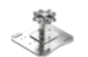 | Base Plate Attachment with Fasteners
 |  |  |  | 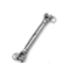 | Turnbuckle
 |  |  |  | 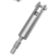 | Shock Absorber
 |  |  |  | 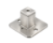 | Intermediate Anchor Post
 |  |  |  | 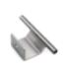 | Cable Guides
SAFETY INFORMATION |  |  |  | 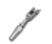 | End Anchor Attachment
- Intended for fall prevention systems only.  - Not designed for lifting applications.  - Do not exceed system design loads.  - Use approved fall arrest PPE.  - Follow manufactured installation procedure.  - Remove from service immediately if damaged or deteriorated, or excessive corrosion is detected. |  |  |  |  | Lifeline Shuttles

